Group 3 Consulting

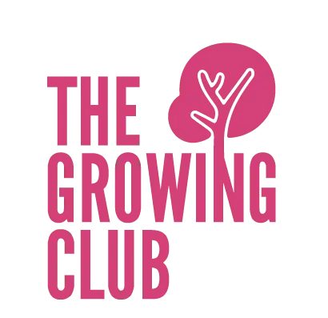
The Growing Club
A report on women’s changing needs through the pandemic

Word Count: 3,298

Student Ids:
Andrew Logue: 38027852
Nora Elhediny: 37980084
Aleksandra Stec: 38165341
Gonzalo Zaballa: 38097575

ACKNOWLEDGEMENTS

We would like to express our great appreciation to our client Jane Binnion, who gave us the opportunity to work with such a great organization. It has been very rewarding to do work for a non-profit and feeling like the research we are carrying out might help women in Lancaster in the near future.

EXECUTIVE SUMMARY

This report aims to display and analyze the data collected for our client Jane Binnion who is the founder of the Growing Club CIC. They provide a fantastic range of skills training and opportunities for women, using a creative and alternative peer support model. Their work is influenced by the Kofi Annan quote, "When women thrive, all of society benefits, and succeeding generations are given a better start in life". The topic was investigated primarily through primary data collection as there was not much use for secondary data in this specific project as our main goal was to analyze the responses we received.
Primary research was undertaken through online and physical surveys that proposed questions about the changes local women have experienced throughout the pandemic and allowed them to share any experiences or opinions that they might have. The questions we created allowed us to identify in which specific ways the pandemic has changed these women’s lives and the needs that have arisen because of it, from receiving specific points of view and the experiences of local residents. The responses were analyzed through the context of Maslow’s Hierarchy of Needs, leading to a couple of key conclusions and recommendations about what the client should do next. Here are the main conclusions which, based on our finding, take into consideration the objectives that our client is working towards:

TABLE OF CONTENTS

COVER PAGE…………………………………………………………………………………………………………..1
ACKNOWLEDGEMENTS…………………………………………………………………………………………..2
SECTION A – EXECUTIVE SUMMARY……………………………………………………………………….2
SECTION B - INTRODUCTION………………………………………………………………………………....4
B.1 Purpose of the project…………………………………………………………………………………………….4
B.2 Objectives of the project………………………………………………………………………...................5
SECTION C - DIAGNOSIS APPROACH……………………………………………………………………...5
SECTION D - METHODOLOGY…………………………………………………………………………........6
D.1 Understanding the data needed……………………………………………………………………….......6
D.2 Collecting data……………………………………………………………………………………………….........6
D.3 Distributing data………………………………………………………………………………………….………..7
SECTION E - DATA FINDINGS…………………………………………………………………………….....7
SECTION F - RECOMMENDATIONS……………………………………………………………………….9
SECTION G - LIMITATIONS……………………………………………………………………………………9
REFERENCES…………………………………………………………………………………………………………10
APPENDIX……………………………………………………………………………………………….............….11

INTRODUCTION

The Growing Club CIC is a social enterprise that was founded in 2016 by Jane Binnion, which provides a fantastic range of skills training and opportunities for women, using a creative and alternative peer support model. They work with "the women left behind", building their confidence and skills to support them towards economic independence for community wellbeing because, "When women thrive, all of society benefits, and succeeding generations are given a better start in life".
As a social enterprise they focus on bridging the gap in skills training and business education for women, with their pre-start up, start up and business growth programs. Their aim is to support local economic growth for community well-being. To begin with, Jane was working with women running small businesses. From here she saw some common themes; isolation from society, working too many hours and getting nowhere fast. She gathered stories of local women running businesses and co-initiated a Lancashire wide conference for women in business to start a change, and present better opportunities.

PURPOSE OF THE PROJECT

The Growing Club wanted us to organize a large-scale consultation with women in the district, regarding what their needs are and what would they want to change or achieve over the next 12-24 months. The aim of this project is to find this out and help The Growing Club, and other service providers respond accordingly, and provide evidence to support their actions.
Our project question is: Which needs have altered the most for women in the local area, as a result of the pandemic (in terms of Maslow's hierarchy of needs)?
More specifically:
- Which needs have be altered the most for women in the local area as a result of the pandemic?

- Have they moved up or down the hierarchy of needs?

- Comparing needs over a time period (beginning of the pandemic, end of the pandemic)
- How have women been affected through lockdown?

Maslow's hierarchy of needs is a theory that looks at people’s motivation, or looks at the order of things that are needed for a person to reach self- actualization - a state in which they are fulfilled and happy and therefore can be productive and motivated at work. There are 5 stages starting with the physiological needs which are basic needs such as food and water, then safety, love and belonging, esteem and finally attaining self-actualization.

OBJECTIVES OF THE PROJECT:

We were asked by our client to organize a survey created for women in Lancaster district. For this, we used a google form as it is the most accessible online survey for our respondents and enables us to get as many responds as possible. It comprises of 10 questions, with 6 regarding needs and 4 regarding demographic such as location or age. All the questions have long-answer boxes apart from age to ensure we get as much data as possible.
Further on in the report we are going to talk more specifically about the objectives of the project, and how we performed them. We are going to describe every step of creating it and present the analyzed data we collected.

DIAGNOSIS APPROACH

According to Schein (1987) in his book: “The clinical perspective in fieldwork”, there are three ways in which consultants can work with clients, the expert mode, which refers to when the client identifies and analyses a certain problem they are having and asks the consultant to come up with a solution, the doctor patient mode, where the client asks the consultant to identify a problem and come up with a solution and the process consulting mode where the consultant and the company work together to identify and solve a problem. Consultants may take advantage of these factors in different aspects of the consultancy project depending on which of these ways they are using to work with their client.
Out of these three ways of dealing with the client, we chose the expert mode since our client had already identified that they wanted to know which needs have emerged for local women in the pandemic. This is so that they could cater their programs and services to those needs, therefore we used the expert mode to collect that information and create recommendations that would help them deliver the best possible service.

METHODOLOGY

UNDERSTANDING THE DATA NEEDED TO COLLECT

When starting the research for this task, we needed to understand essential information from our client. Our first initial meeting involved us asking our clients questions which can be seen in diagram 4d. From the following questions, we understood our client question more clearly. The question is: “Which needs have altered the most for women in the local area because of the pandemic, in terms of Maslow’s hierarchy of needs. According to our client, we understood that Maslow’s hierarchy is a theory they refer to in their everyday work with women at The Growing Club, therefore our job as consultants needed to ensure we included the stages of the hierarchy in our data to understand it’s relevance in answering the question.
In addition, the questions enabled us to find necessary details such as the demographics, as our client wanted to survey women who lived in the Lancaster and Morecambe area. Alongside this, women surveyed also had to be in the age range of 19-63 (working age during the pandemic and for the next 2 years). This was key information and was important as it allowed us to make sure the data we collected was relevant. This also allowed us to start collecting data, as without the parameters our objectives would’ve been too vague.
Alongside collecting data, part of the task involved raising awareness to the issues which impacted women and the work that our client at The Growing Club performed. This will be mentioned more in the report, with part of it being accomplished by putting out surveys to other charitable organizations. The data collected from this report will be used by The Growing Club, therefore understanding the data was essential to ensuring it is up to the best standard and be as helpful as possible.

COLLECTING DATA

The next part in the methodology section focuses on creating the survey and choosing the questions to ask our responders.
After spending some time with our client, we decided as consultants that the best method to collect our data is through surveys and collecting responses online and in person. This allowed us to collect as much data as possible to allow us to have up to date information that wasn’t biased and gives us more detail for analysis. We believe a qualitative approach was better for our project because we were taking into consideration the participants’ opinions and judgements which was necessary to answer the question as it involved the participants’ personal experiences and beliefs. After carefully analysing the questions and statements with our client, we decided on 10 questions, showcased in diagram 4a, 4b and 4c. The aim of the survey was giving the participants’ control and the chance to express themselves to write in detail how the pandemic altered their needs. The best way to do this is giving participants’ the chance to write their own opinions in the survey rather than giving them suggested answers or tick boxes.

DISTRIBUTING DATA

The final stage of collecting data was distributing the surveys and resources. We did that in a variety of methods to allow us to distribute to as many participants as possible and receive results in a quick manner too, allowing us to start the data analysis promptly.
One of the distribution methods was through online circulation. This was done in a variety of ways such as sending links to individuals and group chats to share with friends and relatives and some of our university peers. Even though responses from university wasn’t necessarily a keen option from the client initially, it provided insights from a range of views therefore proved beneficial to the results.
Other distribution methods involved circulating our surveys through different social enterprises which were given by our client such as the Tara Centre and the West End Community Centre. These were then distributed through their own websites and newsletters.
Our main aim was maximising responses to gather the largest amount of data possible therefore we could not just rely on online responses. Although online responses are easily collected and can be distributed quickly, we realised they weren’t very reliable, and we couldn’t guarantee responses therefore we decided doing collecting data in person was also a way which we distributed data which guaranteed some responses.

FINDINGS & ANALYSIS
See appendix for referenced figures

As shown on diagram 1a, out of the total 199 responses the most requested kind of support during the pandemic was social at 33.2%. This comes as no surprise to us, as every woman in the Lancaster district will have been subject to Lockdowns and Isolation at times. This could've also influenced as the 55 responses requesting emotional support, as one of the respondents summarized in their statement "Emotional - especially would've been nice to get support socializing again as it does wonders for mental health". Financial support was also cited as the 3rd most requested form of support at 21.1%. This is most likely due to many women being off work or on furlough pay, especially when bills are higher due to more people being at home. Wellbeing also had a total response of 9.5%, leading us to believe that although some people believed it was a form of support they needed, it didn’t take priority. The lowest response was training at 8.5% of total responses. The 4 people that fit this category cited the need to be able to adapt to remote working and get up to speed on new software.
Diagram 1b shows a wider range of responses. This is due to the pandemic not yet having had an impact on women's lives. The most chosen need before the pandemic was financial, with 64 / 199 responses. The reason for this is that financial stability is one of the main goals for any person, and without a strong need for another factor many will choose this as their primary need. Social and training are the 2nd and 3rd most chosen responses, most likely due to a significant portion of our responders being students with priorities on work or making friends. Self-fulfilment and work-life balance take up 30 and 22 responses respectively, with many women wanting to make the most out of their lives alongside balancing a new business, a family, or studies. Emotional and wellbeing only share 11 responses combined, with one of the responders stating that they needed emotional support when life became stressful and found it unclear where they could go for help.
165 women feel that their biggest change in needs since the pandemic began was social, wellbeing and financial (see Dia.1c). Many responders stated that they felt lonely and isolated during the pandemic, as they have not had to deal with being restricted like this before. As a result, they often turned to socializing to cure loneliness and boost morale. As women were also faced with furlough pay or being off work entirely, 22.6% faced stretched finances. As the pandemic had a serious physical effect on some women's lives, many focused more on their own wellbeing to ensure they didn't get ill. Compared to the previous chart, we can see that there was an 8.6% increase in women that chose they needed emotional support compared to before the pandemic. This has obvious correlation to the uncertainty of work and lack of social contact faced by many during this time.
Diagram 1d showcases what women’s needs are currently (during this period of the pandemic). Like the previous question, the chart is mostly taken up by wellbeing, social, and financial needs. This is due to the amount of time that the pandemic has gone on, with more people falling victim to increased bills, whilst physical and mental health suffered at the expense of lockdowns. At this point, we also see the introduction of motivation as a need. 10 individuals cited that they had become lazy since the introduction of home-working and needed a boost to have a positive outlook and work efficiently. Training also had an increase of 5 responses. There isn't a clear reason for this, however one factor that could possibly affect it is the return to in-person work. Many women may feel they need retraining on physical tasks after they have been absent for so long. Furthermore, 30 women stated their main need as freedom – a clear indication that the cause of many problems were the restrictions placed upon them.
Many women experienced significant changes to their daily routine. As shown in diagram 1e, 80 women chose the biggest impact to their lives as being a shift to home working. One response that accurately depicted many was that "I stopped working my part time job due to lockdowns, meaning I had less to fill my day with. I got quite bored when the 1 - time outside rule was introduced as well". This perhaps influenced the 68 responses under ‘isolated’, with women not being able to socialize either in the workplace or with friends, particularly if they lived alone. The other 51 responses that were grouped were under self-amusement and remote activities. As many women couldn't meet up with friends in real life, they took to finding ways to enjoy their own time alone and took up remote activities such as online exercise classes over zoom.
What women see their needs being over the next 12-24 months was varied, presented in figure 1f. A few responses were indecisive, citing it was hard to look into the future when it was so unpredictable. However, 60 women still chose socializing as being their primary need. As one woman answered there was a lot to "catch up on", especially with people that they haven't been able to meet in years. It seems there is a sense of needing to try and recover the lost time by socializing a lot more in the future. Second to this was stability and financial needs at 29 responses each, with women citing “Continued stability as my life gets back to normal” and “Keeping a stable job”. Wellbeing and training share 27 and 24 responses each, including “Staying healthy” and “Continued support with studies”. Finally, self-fulfillment was chosen by 22 women, perhaps ones who weren’t as affected by the pandemic as others and therefore need less ‘recovery’ time. Those with long-standing emotional problems may still need emotional support, as shown by the final 8 responses.
As we are constricted on word limit, information on the demographic of responders can be seen in the appendix through diagrams 2a, 3a and 3b.

RECOMMENDATIONS

There are a couple of changes and adjustments to the courses that The Growing Club offers that we can recommend based on the on the information we have collected and the findings we have uncovered.
One of the courses currently offered by The Growing Club is Employment & enterprise skills for women. This course already teaches skills and communication skills, which is great as many women’s greatest need was a boost meeting people, whether that be through teaching skills or introductions. To bolster this approach, we believe it would be a good idea to teach women how to maintain contact with others, as well as how to communicate certain needs with another entity. This would allow women to build a stronger sphere of contact and therefore not become as isolated during lockdowns or times of crisis.
Another course that the growing club offers is “Roots and Shoots”. As this takes women through the process of building a start-up, we believe that it will be beneficial for The Growing Club to teach more in-depth financial advice. This is because many women faced uncertain finance and income sources during lockdowns and having the knowledge on how to properly manage income during instability will be vital if any situation similar occurs in the future. Furthermore, we recommend that women involved in this program get taught about any financial support they can receive during times of difficulty. This can be from government subsidies to different grants.
Finally, we will look at the “Bloom and Grow” program. This offers to help women balance the work-life balance of running a business, potentially alongside having a family. As a result of our findings, we think that it would be helpful for women to be taught stress relief tactics and activities. This is since many women throughout our surveys citied have emotional distress at the large workloads faced. If women can utilise techniques to help deal with their emotions, they are more likely to be able to think clearly and manage a business more effectively. As mentioned previously, giving women information on who to go to when they need support is vital in ensuring a successful work-life balance.

LIMITATIONS

As this was a small-scale project, we were limited in time and resources. This made it hard to gather many responses. If we had the ability to conduct this project in a larger scale, we would survey more people - however that would need a larger timeframe and perhaps a larger team of consultants. Many organizations were slow at responding to emails, meaning responses were coming in slow and as a result we didn’t get as many answers. Furthermore, some responses were not in-depth enough for a large amount of analysis, therefore we couldn’t do much with them. Finally, we could’ve hoped for a more even spread of responses to give a more accurate depiction of all women’s needs. Having said this, we still managed an even spread.

REFERENCES

Schein, E. (1987). The Clincial Perspective in Fieldwork. Los Angeles: SAGE.

APPENDIX

Diagram 1a
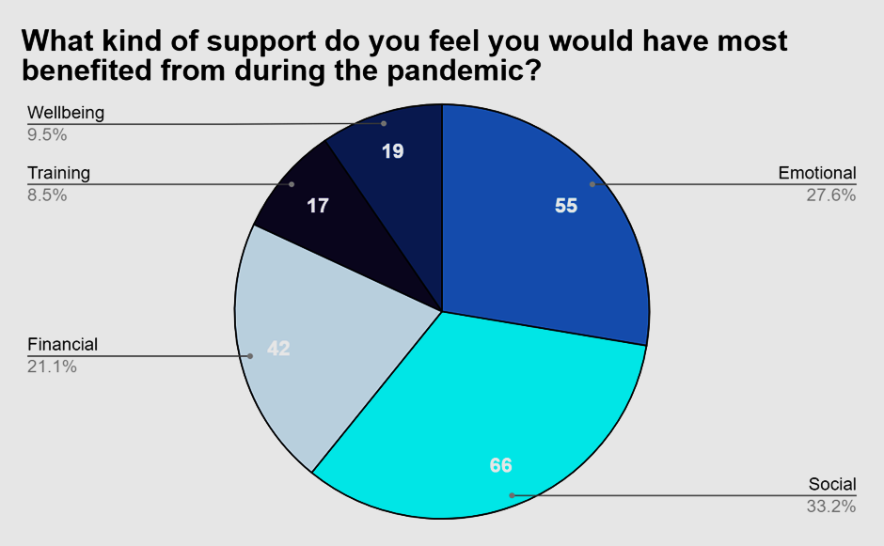
Diagram 1b
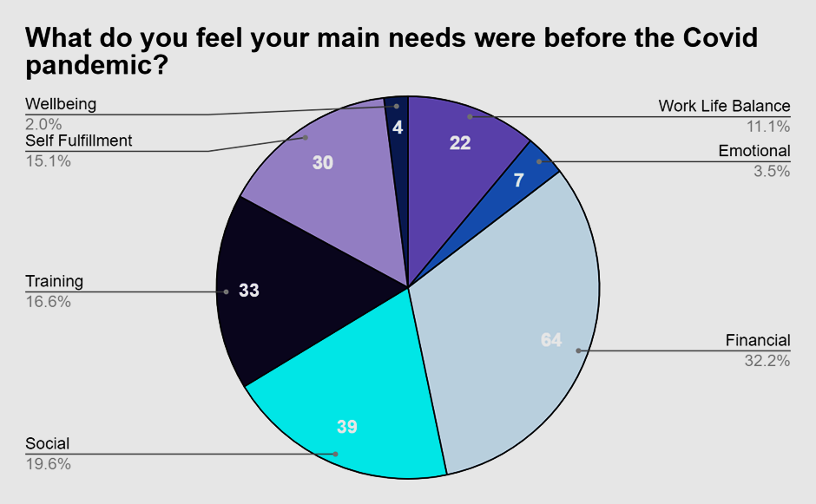
Diagram 1c
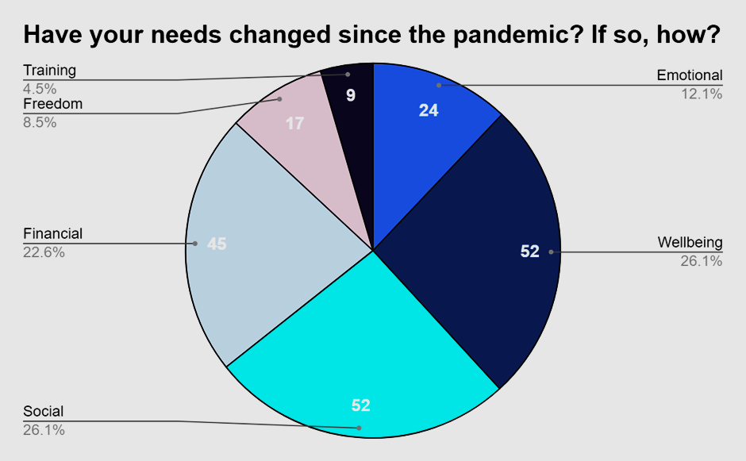
Diagram 1d
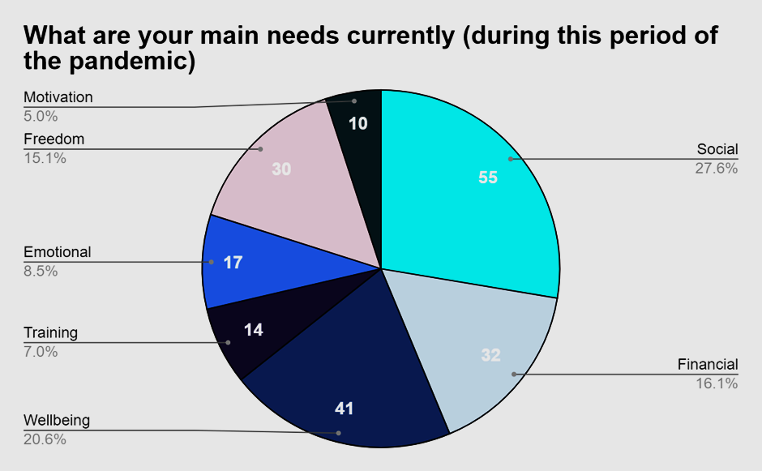

Diagram 1e
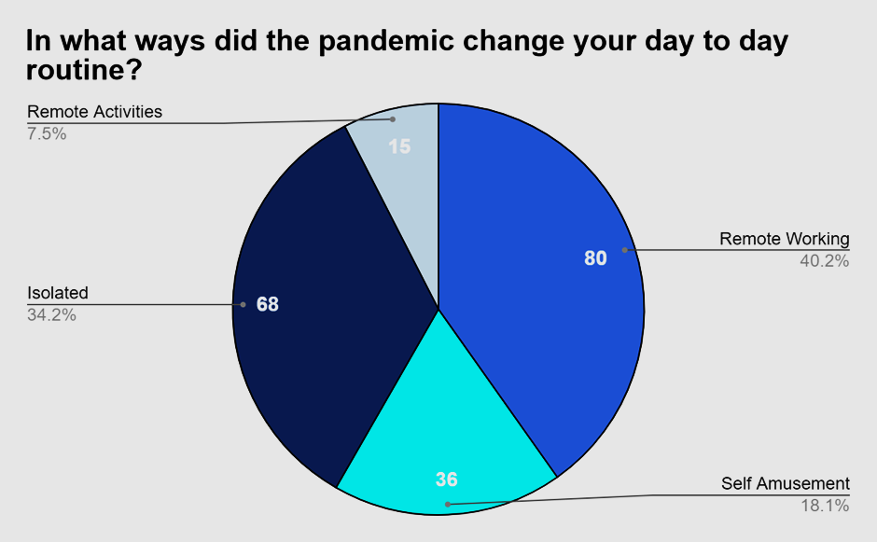
Diagram 1f
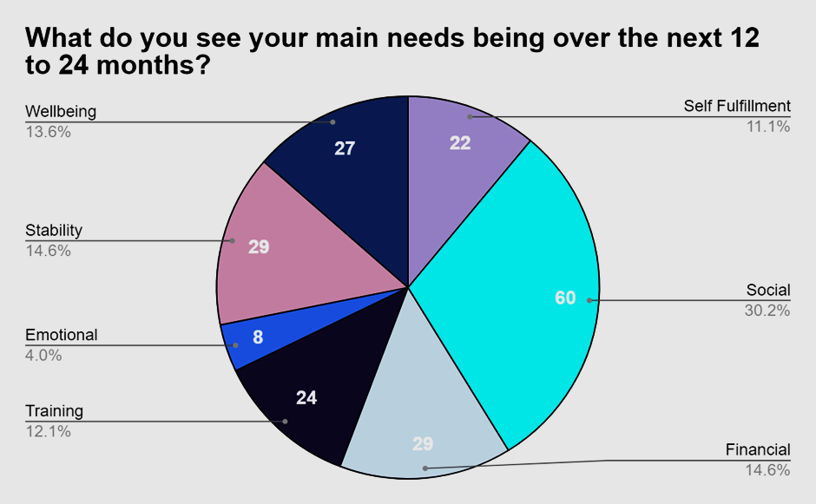

Diagram 2a
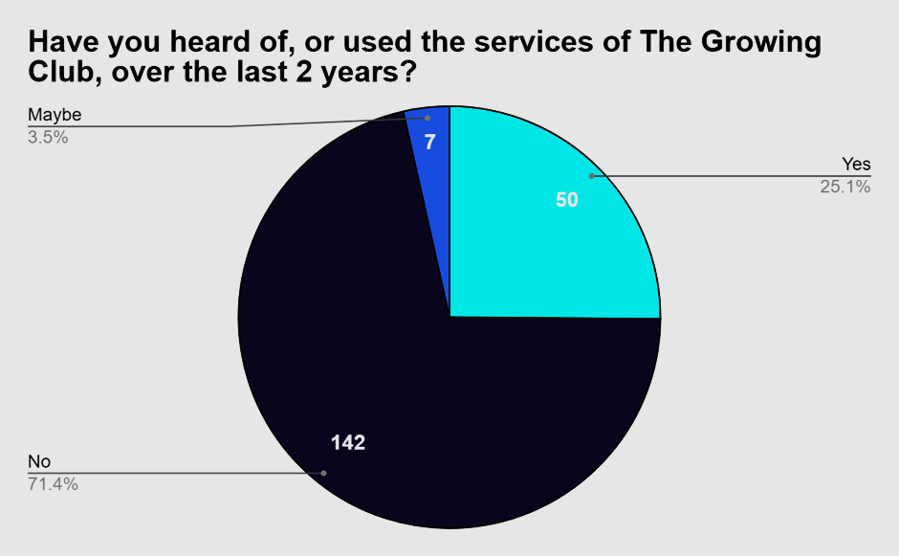
Diagram 3a
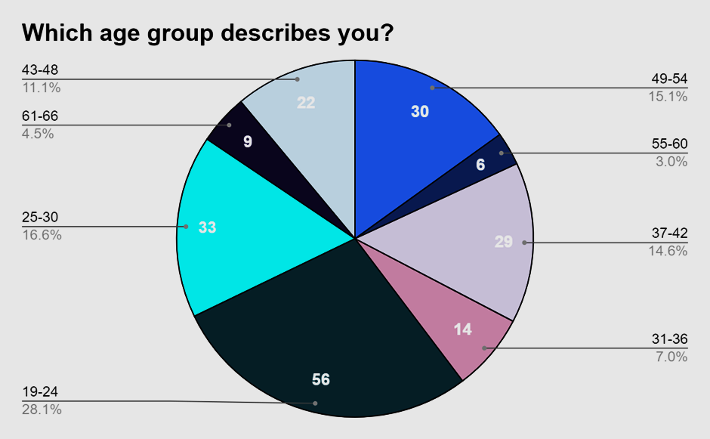

Diagram 3b
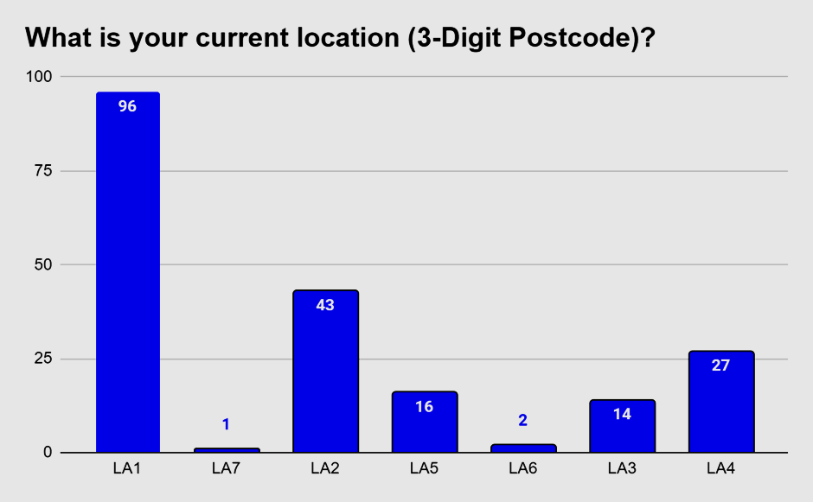

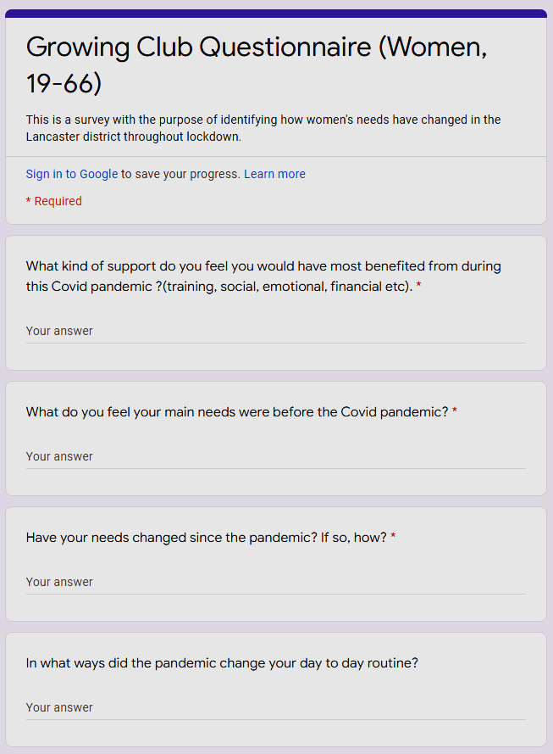
Diagram 4a

Diagram 4b
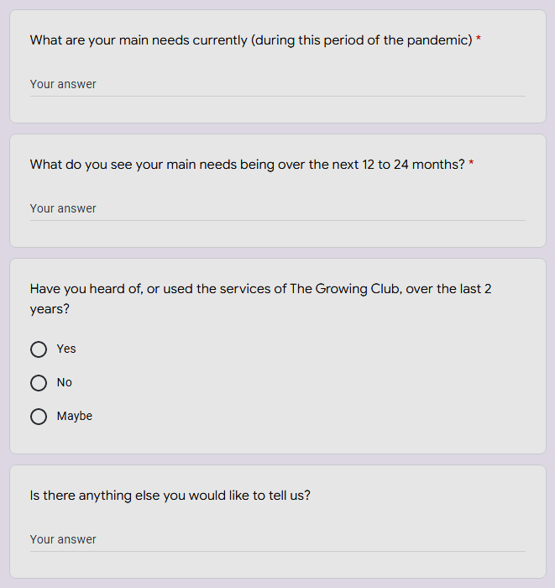

Diagram 4c
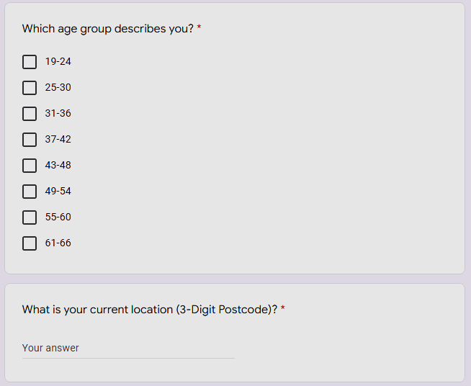
Diagram 4d
